 | Twitter | LinkedIn | Visuals
1 | 📢 Attention #SMEs!  ❔ Did you know that all the information you require to support your company's #digital #acceleration journey is now available in one place?  Simply visit the 'Information for companies' section on the #EDIH_Network website 👉 https://bit.ly/48qOT9V | 📢 Attention #SMEs!  ❔ Did you know that you can now find all the information you need about how the #EDIH_Network can support your company's digital acceleration journey in one place?  Simply visit the 'Information for companies' section on the EDIH Network website to discover insights on various digital challenges 👉 https://bit.ly/48qOT9V
2 | 🚀 Accelerate your company’s digital transformation!  Gain access to innovative services, technical expertise, advanced digital technology, financing advice, training, and more.  Visit the 'Information for companies' section on the #EDIH_Network website 👉 https://bit.ly/48qOT9V | 🌐 Accelerate your company’s #digital #transformation with #EDIH support!  🚀 Improve business and production processes with the use of digital technologies by gaining access to technical expertise, financing advice, staff training and upskilling opportunities, and more.  Learn more by visiting the 'Information for companies' section on the #EDIH_Network website 👉 https://bit.ly/48qOT9V
3 | 🔍 Is your company ready to navigate the continuously evolving #digital landscape and reach unprecedented levels of success?  🌟 The #DigitalSpeedTest is crafted to help you swiftly evaluate your company’s digital maturity.  Find out more here 👉 https://bit.ly/3RRJCCS | 🧐 Is your company prepared to navigate the ever evolving #digital landscape and achieve new heights of success?  🚀 The #DigitalSpeedTest is designed to assist you quickly assess your company’s #digital level and find the most suitable EDIH through the #EDIH_catalogue.  Learn more 👉 https://bit.ly/3RRJCCS | 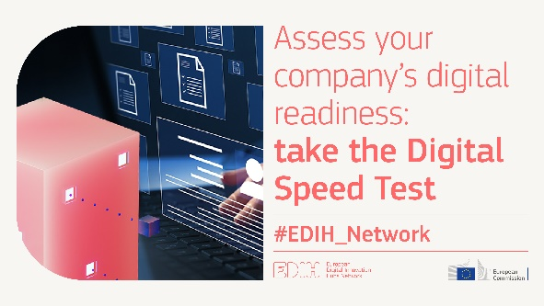
4 | 📢 Introducing the Network of European Digital Innovation Hubs!  🌐 Browse this #infographic & discover how you can digitally #transform your business and stay ahead of the curve with the expert guidance of the #EDIH_Network.  Access it here 👉 https://bit.ly/48ZMF1u | 📢 Introducing the Network of European Digital Innovation Hubs!  🌐 Interested in increasing your company’s competitiveness, enhancing its infrastructure, and boosting your success? Download this insightful #infographic and learn how you can harness the power of #digitalisation with the expert guidance of the #EDIH_Network.  Access it, here 👉 https://bit.ly/48ZMF1u | 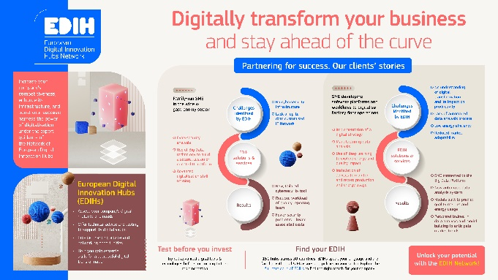
5 | 🔍 In search of the most suitable European Digital Innovation Hub near you?  🗺️ Browse our interactive #EDIH_Catalogue, select from three hub types and filter by criteria like country, sector, technology and more, to find the right fit for your company.  Learn more by visiting the #EDIH_Network’s website 👉 https://bit.ly/3uXWEG6 | 🔍 In search of the nearest & most suitable European Digital Innovation Hub?  🗺️ Explore our interactive #EDIH_Catalogue, where you can choose from three hub types and filter by criteria like country, sector, technology, and more to find the perfect match for your company’s needs.  Learn more by visiting the #EDIH_Network’s website 👉 https://bit.ly/3uXWEG6 | 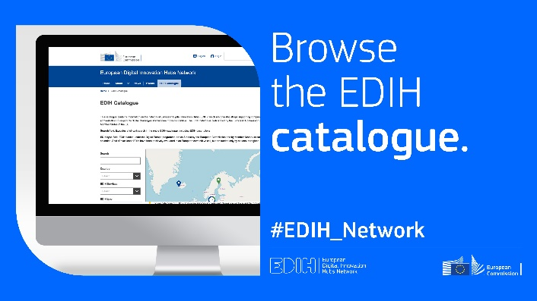
6 | Discover the #EDIH_Network, the EU initiative guiding European companies into the digital age.  Access key services like  🔍test-before-invest,  🎓 skills & training,  💼 financial advice,  🤝 networking.  Watch the video and explore how the #EDIHs can help your business | Explore the #EDIH_Network, the EU initiative guiding European companies into the digital age.  Access essential services such as  🔍test-before-invest,  🎓 skills & training,  💼 financial advice,  🤝 and networking.  Watch the video to discover what the #EDIHs can do for your business | EDIH Network - VIDEO

